LAB 2: Motor Control, Robot Arm Kinematics and Path Planning

For this lab you will need to do the following:

1. **2-DOF Robotic Arm**
2. **Propose a 2-DOF Arm LEGO design and build it. Take into account the following requirements:**
3. Add a pencil, marker or pen to the end effector.
4. For simplicity, keep the two revolute joints on the same plane (speak to your TA first if you'd like to try something else).
5. Add a base to the robot arm in order to keep it fixed and aligned with the reference frame.
6. Are there different types of linkages that can provide the same motion? Consider pros/cons of different motor mountings and arm linkage constructions (see lecture notes).

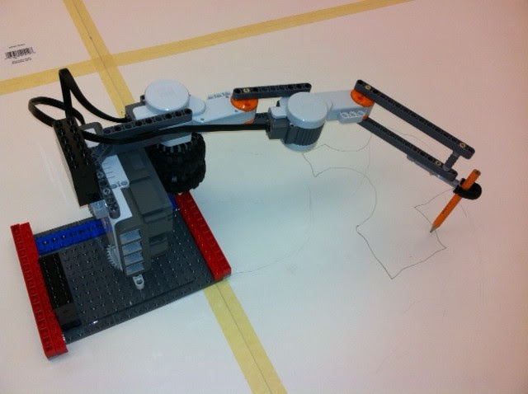

1. **Determine the workspace of your robot. Include a figure and dimensions of your workspace in the report.**
2. **Forward Kinematics**
3. **Define an initial position for your robot, such that the robot base is located on (0,0) Cartesian coordinates.**
4. **Write a program that given two angles, the robot moves to their corresponding joint angles, and returns the (x,y) position of the end effector. Measure the accuracy/repeatability of these movements to include in your report.**
5. **Implement the following programs to give your robot the functionality of measuring distances and angles in a 2D plane:**
6. Distance: Inside the robot working space, a user wants to measure the distance between two points. The user moves the end effector to the first point, clicks a touch sensor for recording the first point, then the user locates the end effector over the second location and clicks for storing the second point. The user gets as output the distance between the two points and it is displayed in the EV3 screen (or terminal).
7. Angle: Inside the robot working space, a user wants to measure the angle between two lines that intersect. The user moves the end effector to three points: the first point in the line intersection and the other two on the different lines. The user gets as output the angle between the two lines and it is displayed in the EV3 screen (or terminal).
8. **Inverse Kinematics**
9. **Implement both the numerical (Newton's or Broyden's Method) solution and an analytical solution for the following programs:**
10. Position: Write a program that receives as input a (x,y) location inside the robot working space and moves the robot end effector to the input location.
11. Midpoint: Write a program that finds the midpoint between two points. i.e. The user moves the end effector to point 1 stores that location then moves the end effector to point 2 stores the second location and then runs the midpoint algorithm which calculates and moves the robots end effector into the middle location of the two points.
12. **Explain, compare, and analyze both approaches in your report.**

**The following problems are optional:**

1. Denavit-Hartenberg Parameters: Build a 3DOF robot arm. Calculate the Denavit-Hartenberg parameters for your robot arm, or compose the link matrix transforms. Please include an image or diagram of your robot indicating frames of reference and links measurement. Add your calculations in the report.
2. 3DOF Inverse Kinematics: Write a program that locates the robot end effector to a given (x,y,z) coordinate.
3. Manipulation Task: Propose a manipulation task that can be solved with your robot arm. e.g. write a program that receives as input a 2D image and controls the robot to draw the input file. Explain your approach in the report.

**Grading:**

Demo:

* Points 2 and 3.

Hand in:

* A PDF report answering the questions from each assignment section. Include images of your robot and explanations for the approach and workflow.
* A .zip electronically on eClass. The zip has to contain your implementations (.py files) and any data you either measured or generated.